**Faculty of Engineering URSource Functional Requirements Document**

**Team name: Software Group B**

**Team members: Avery, Renz, Nick, Jiahao, Jinkai, Mckenzie**

**Section 1**

Introduction:

We are Software Group B. The project is to update and improve the University of Regina’s Engineering website providing suggestions, information and a prototype of the new website for staff, admin and students.

1.1 Purpose:

The purpose of the project is to increase the functionality of the current system. Functionality requirements to be addressed are, intuitive movement system, structured file naming, and an easy to maintain site.

Purpose of website for Students

Be able to find specific program information and requirements

Course Schedules

Information on Faculty Members

Purpose of website for Staff/Faculty

Find information on advising, lecturing, transfer and override forms etc

Upload documents and update website

1.2 Scope:

The main system is the Engineering website, with a focus on internal content. This document addresses requirements, assumptions, and seeks to address rules for naming, and file structure. Keeping the website simple and intuitive, by breaking down and re evaluating current website. This will address the main purpose and give ideas of how to improve the current system website through a reevaluation of setup.

1.3 Background:

The current system is older and contains many files with no set naming conventions to display version and date updated easily. This creates problems in the P drive and website as files may be outdated and potentially reuploaded. Make the site future proof and usable and helpful for future students.

1.4 References

Meetings:

Met with Meigan: addressed staff and faculty concerns for the website and gave insight from an admin perspective of issues to be resolved mainly dealing with intuitiveness.

Met with Glenn: overviewed how to create a site and how seperation of groups can create file problems and maintenance problems.

Group Meeting: Went over past meetings main points, addressed common concerns and brainstorming based off of experience with the current system.

1.5.1 Assumptions

Currently the file system needs to be updated and is a main concern, current system doesn’t have set rules. New file system with be implemented and followed.

1.5.2 Constraints:

Overall outcome and design of the website will be determined by the faculty.

Meetings with faculty and staff throughout the project will be limited.

Website design will be potentially limited by use of URSource Cascade system.

1.6 Document Overview

The document is organized into an overview of the project definition, methodology of design and idea generation,overview of requirements: user and functional requirements, hardware, software and security requirements.

**Section 2**

Methodology

Ideas are generated individually, reevaluated as a group and then checked against project requirements.

**Section 4**

4.1 Context:

Staff use the system to update information for faculty and staff, update events and site pages with up to date information. They also get information such as forms and files for transfers, overrides etc.. Student users retrieve files and get information from the website but don’t send information. IT update the site but don't retrieve information. These relationships are displayed below.

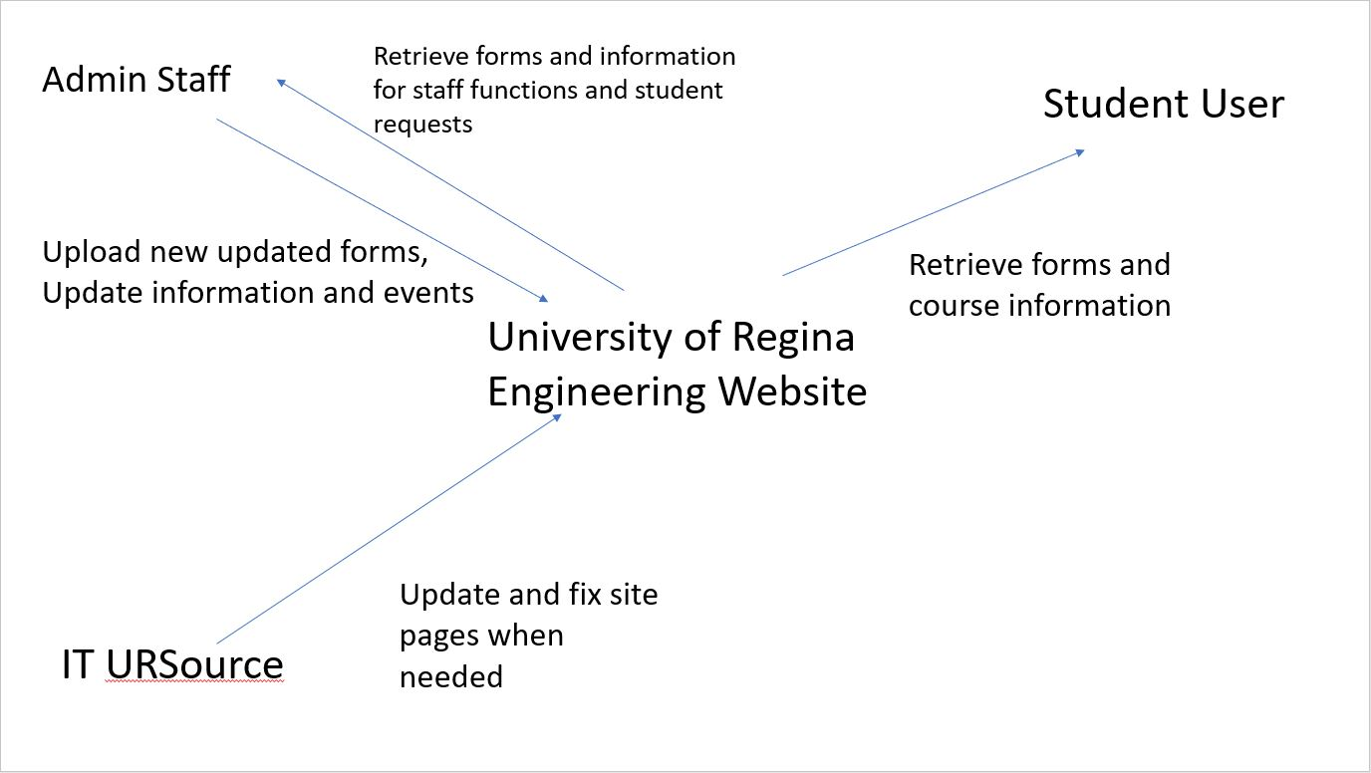

4.2 User Requirements

Below are requirements separated into groups, consistent user requirements are easy to use and user friendly.

Staff requirements:

Intuitive file naming conventions

Updated file separation

Easy to access and manipulate

IT requirements:

Simplistic easy to update

Low need for maintenance hours

Students:

Easy to access

Intuitive links and forms

4.5 Functional Requirements

Allow version history for files and forms

Easy for admin staff to add to in the future

**Section 5**

5.1 Interface Requirements

Website to display information to users

URSource to display and easily make changes to the website

5.1.1 Hardware Interfaces

University of Regina Servers

5.1.2 Software Interfaces

URSource

5.4.1 Security and Privacy

Security and privacy is a concern in the respect of permission groups as highly personal information is hosted on the site and retrieved when needed. The consideration is to ensure the data is not accessed by those without permission and without valid reasons. Personal information could be seperated to only admin or specific staff, program information could be separated to those in the program and other information separated as needed. A log-in status would be necessary for the use of roles being implemented although public information should always be available.

5.4.2 Audit Trail:

Version history is in place for the pages on URSource and can be made as the active page when needed.

File version history could be considered and implemented to ensure up to date forms are being used and identified old versions and equivalent new forms

As a group, audit history should be used to track changes of group members to ensure changes are agreed upon and changes with issues or concerns can be addressed and reverted if needed.

5.4.3 Reliability:

Critical software failures may result in loss of employee productivity and in extreme cases of time sensitive form submission, issues applications. Acceptable reliability would be consistent reliability for anytime use by all users, minimum reliability would be during business hours for use by staff and students.

5.4.4 Recoverability

Data submitted to the website must be backed up in case of a crash for easy recovery and low down time of the website.

5.4.5 System Availability:

The system should always be available to help students access information during non business hours and weekends as well as faculty and staff accessing information at those times as well.

5.4.6 General Performance:

The website has to have a fast response time for staff to access necessary files for requests quickly and efficiently.

5.4.7 & 5.4.8 Capacity and Data Retention:

Data should be able to be stored with growth for the future, large data storage availability and a rehaul when capacity is approached would be appropriate.

Data should be retained as long as forms and files are applicable and keep at least one version for safety and reassess files uploaded yearly or bi yearly so information stay relevant.